**Oracle Lab 11: Triggers**

***Assoc. Prof. Dr. Nguyen Thai Nghe***

*Refer to this link* <http://plsql-tutorial.com/plsql-triggers.htm>  *for learning Triggers*

*Save to* ***StudentID-lab11****.sql*

**General Syntax to create a trigger is:**

CREATE [OR REPLACE] TRIGGER trigger_name

{BEFORE | AFTER | INSTEAD OF }

{INSERT [OR] | UPDATE [OR] | DELETE}

[OF col_name]

ON table_name

[REFERENCING OLD AS o NEW AS n]

[FOR EACH ROW]

WHEN (condition)

BEGIN

--- sql statements

END;

**Example 1:**

Create a trigger to trace who has edited the salary (sal column, in the emp table) of an employee.

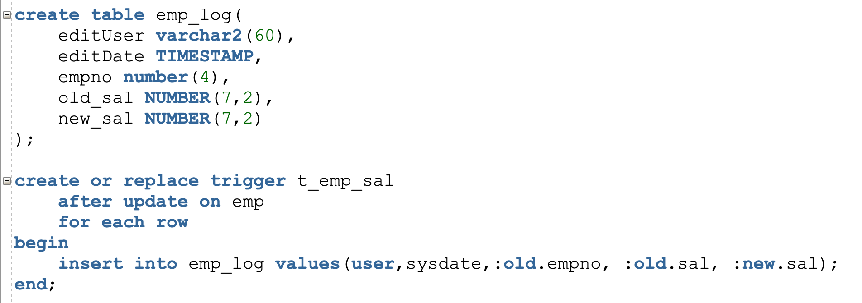

**Example 2:**

Create a trigger to check the following criteria when the user insert or update data (on emp table) :

* Sal > Comm
* New sal > old sal
* New sal can not be higher than 10% of old sal

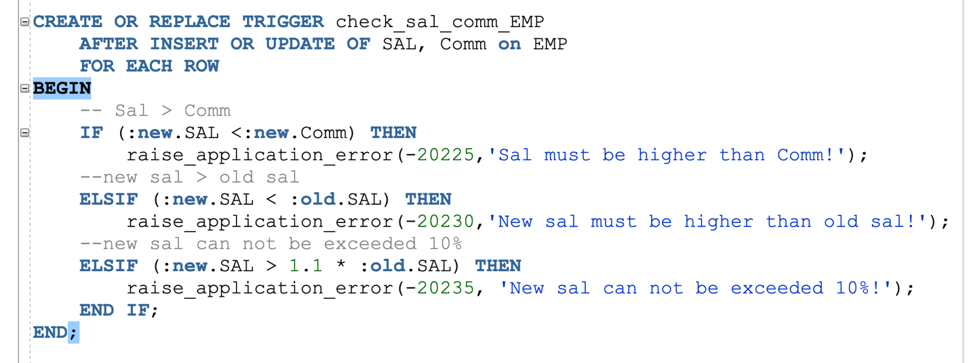

Test this trigger by updating the data to check 3 above criteria

**Example 3:**

Create a trigger to check that the new salary or updated salary can not exceed the budget in each department.

* Alter table Dept to add a Budget column
* Input data for this column (budget > total_sal, using the following statement)

select deptno, sum(sal) as total_sal

from emp

group by deptno;

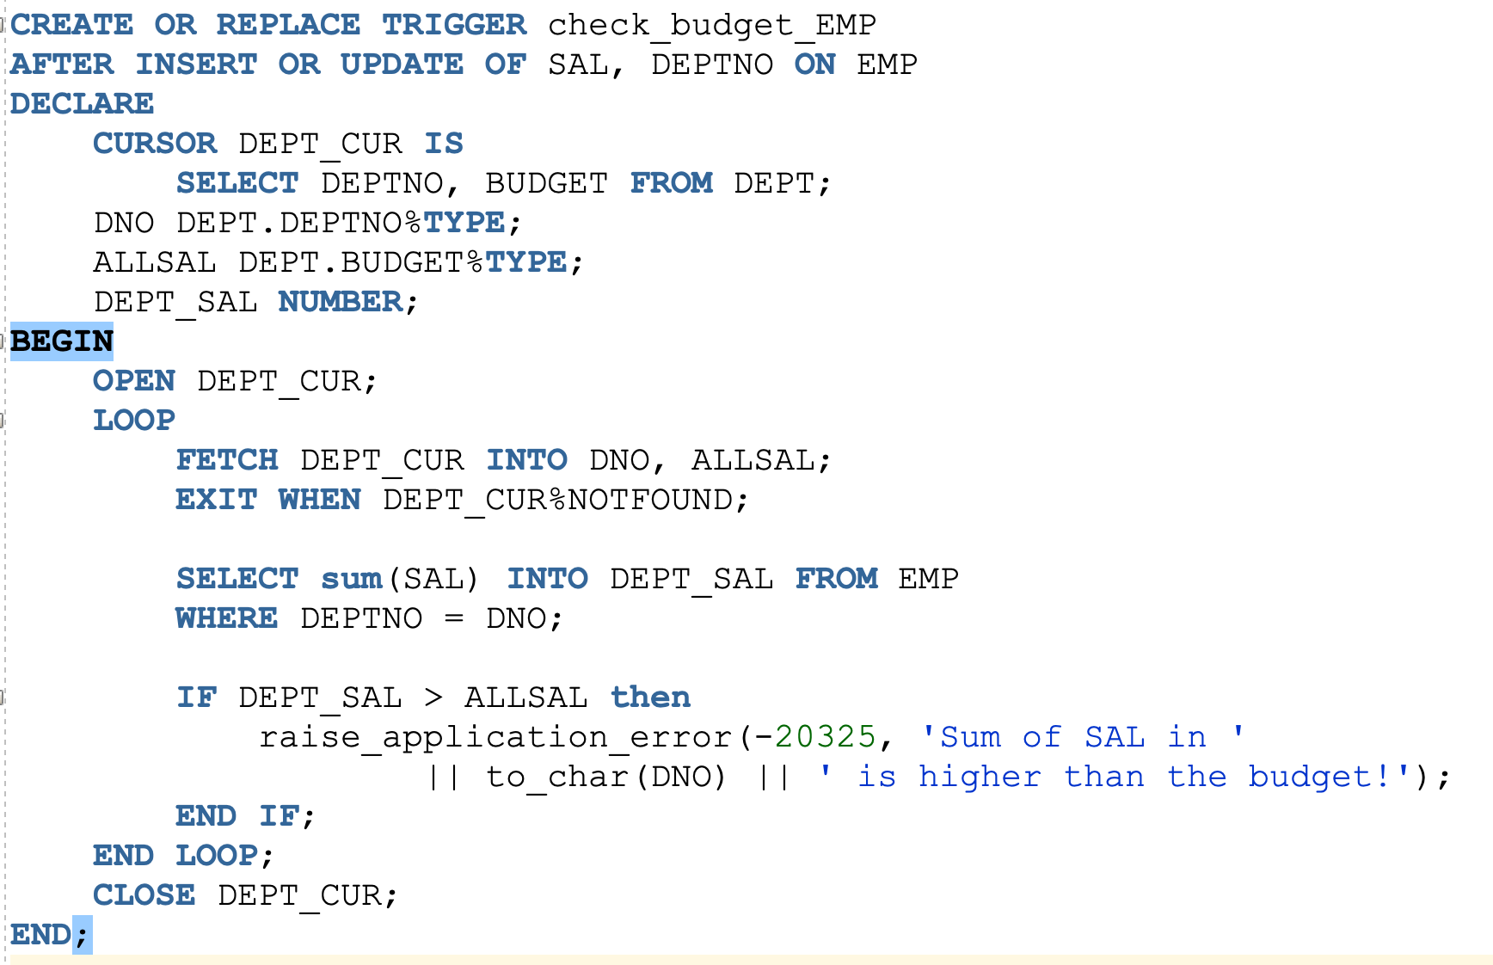

Update salary of an employee to check above trigger.

**Exercises (using Scott schema)**

1. Write a trigger to store who/when/whom deleted an employee (emp table). Test it
2. Write a trigger to trace who/when edited the “comm” of an employee in the emp table. Store old and new values.
3. Complete examples on <http://plsql-tutorial.com/plsql-triggers.htm>

**Write at least 3 triggers for your progress exercises**

**1. Write a trigger to store who/when/whom deleted an employee (emp table). Test it**

Check the **emp** table

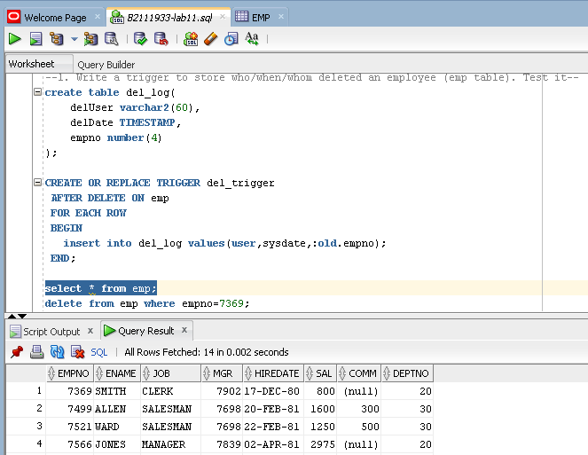

Delete an employee

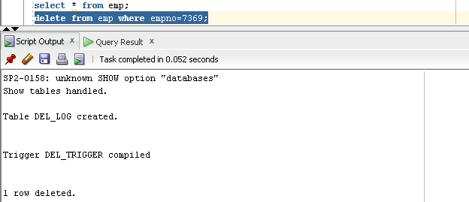

After delete

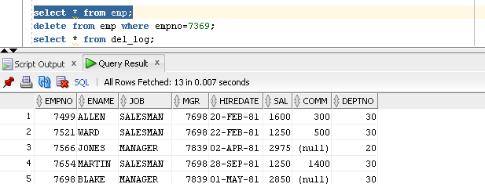

Check log

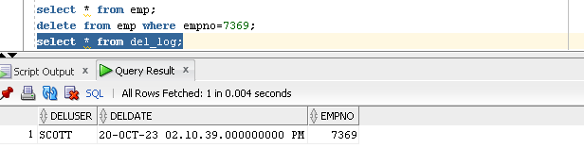

**2. Write a trigger to trace who/when edited the “comm” of an employee in the emp table. Store old and new values.**

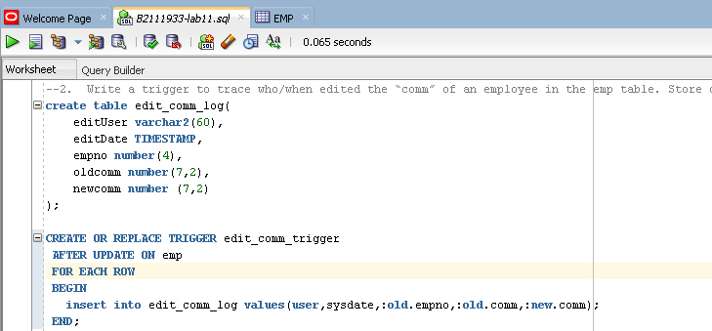

Before update

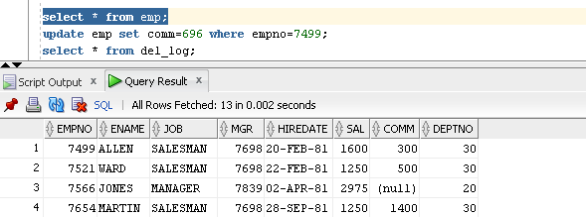

After update

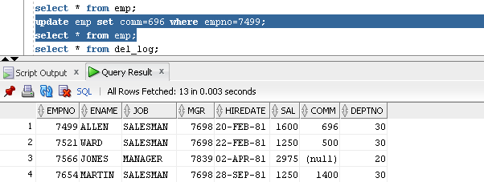

Check log

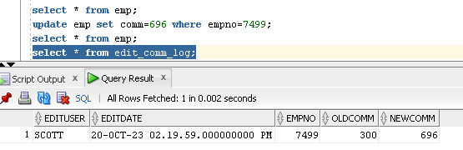

**3. Complete examples on** [**http://plsql-tutorial.com/plsql-triggers.htm**](http://plsql-tutorial.com/plsql-triggers.htm)

**Write at least 3 triggers for your progress exercises:**

1. **Delete User**

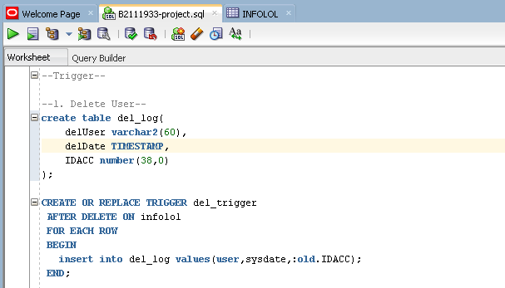

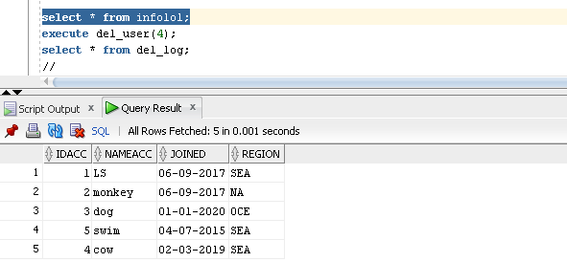

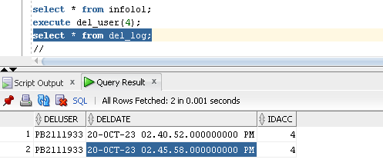

1. **Edit Name**

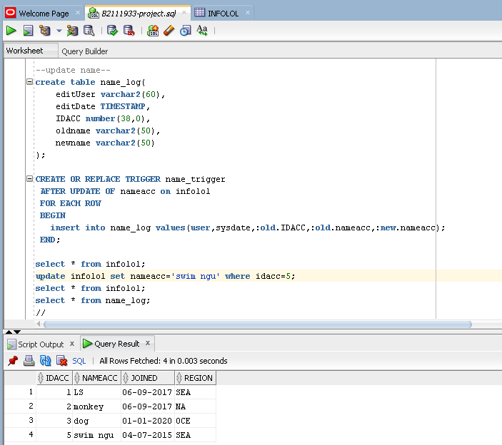

1. **Update Rank**

